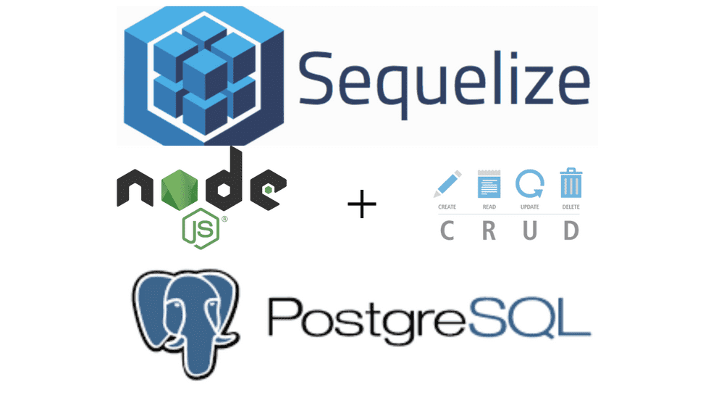

Performing CRUD with Sequelize

What is Sequelize

An ORM library is a completely ordinary library written in your language of choice that encapsulates the code needed to manipulate the data, só you don’t use SQL anymore; you interact directly with an object in the same language you’re using.

Sequelize is a promise-based Node.js ORM for Postgres, MySQL, MariaDB, SQLite, and Microsoft SQL Server. It features solid transaction support, relations, eager and lazy loading, read replication and more.

However Sequelize supports sevaral other database clients, this article focuses on using Sequelize with Postgres. We will be building a simple blog where users can create posts, view posts and add comments to a post.

Setup project

Requirements:

- NodeJs installed
- npm or yarn installed

To start the project type:

yarn init

and configure initial informations about project like:

[wells@wells-pc node-crude-sequelize]$ yarn init
yarn init v1.19.1
question name (node-crude-sequelize): node-crude-sequelize
question version (1.0.0): 1.0.0
question description: this project implements a basic crude with nodejs, express, sequelize, postegree and jest
question entry point (index.js): index.js
question repository url (https://github.com/wellsousa/node-crude-sequelize.git):
question author (wellington de sousa reis <wellsousa1987@outlook.com>):
question license (MIT): MIT
question private:

If you have not created an express project, quickly do so :

yarn add express

and open the project in a terminal. At the root folder of the project, run the following commands to install necessary depencies:

yarn add sequelize sequelize-cli pg pg-hstore

A brief explanation about the libraries installed in the command above:

sequelize is the Sequelize library itself.
Sequelize-client is a package that enables us interact with the database through sequelize from the CLI.

Pg is Postgres client for nodejs.

Pg-hstore is a node package for serializing and deserializing JSON data yo hstore format.

Next up, let’s create sequelize config, to do that, run the command below to create a file called sequelizerc:

touch .sequelierc

Copy the code bellow int the .sequelizerc file:

const path = require('path')

module.exports = {
config: path.resolve('./database/config', 'config.js'),
'models-path': path.resolve('./database/models'),
'seeders-path': path.resolve('./database/seeders'),
'migrations-path': path.resolve('./database/migrations'),
}
Sequelize uses the .sequelizerc file to generate the conifg and the model using specified path. Next up, we generate the config by running te command bellow:

yarn sequelize init

or, if you have global sequelize installed:

sequelize init

Now, you should have a new directory called database with a scaffolding as shown bellow:


Next up, let’s edit the database/config/config.js. Replace the content of file with the code bellow:

require('dotenv').config()

module.exports = {
development: {
url: process.env.DEV_DATABASE_URL,
dialect: 'postgres',
},
test: {
url: process.env.TEST_DATABASE_URL,
dialect: 'postgres',
},
production: {
url: process.env.DATABASE_URL,
dialect: 'postgres',
},
}
Since our focus is on using Sequelize with Postgres. We’ve streamlined the config to be Postgres specific.

Since we are using Postgres, we’ll be using connection string to connect to the database. Create two Postgres databases one for develepment and one for test(if you need test for your project).

